Geometry: Unit 10, Lesson 8

- The value $16.5$ is half the difference between a number, $x$, and $32$. What is an expression that can be used to find $x$?

$$\frac{x-32}{2}=16.5$$

- What is half the difference of $45$ and $17$?

14
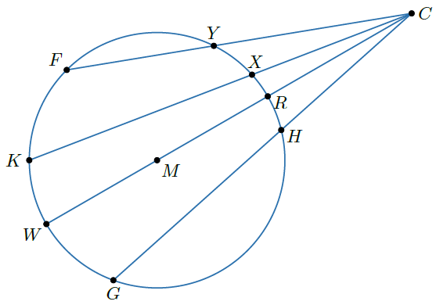
- Circle $M$ has points $F$, $K$, $W$, $G$, $H$, $R$, $X$, and $Y$ on the circle. Secants $\overline{FY}$, $\overline{KX}$, $\overline{WR}$, and $\overline{GH}$ intersect at point $C$ outside the circle. What two arcs does angle $WCG$ intersect?

$\hat{WG}$ and $\hat{RH}$

